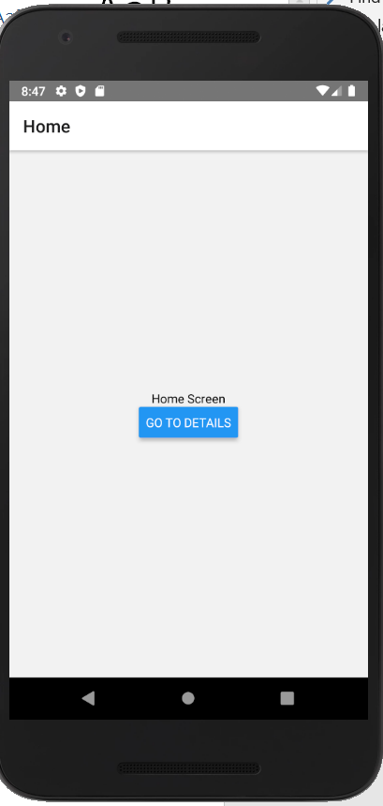 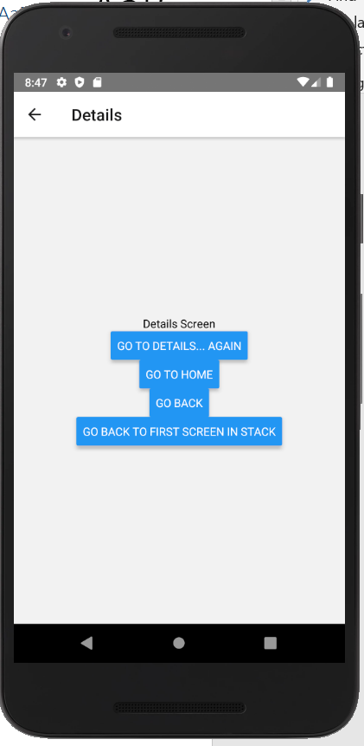

// In App.js in a new project

import \* as React from 'react';

import { Button, View, Text } from 'react-native';

import { NavigationContainer } from '@react-navigation/native';

import { createStackNavigator } from '@react-navigation/stack';

function HomeScreen({ navigation }) {

return (

<View style={{ flex: 1, alignItems: 'center', justifyContent: 'center' }}>

<Text>Home Screen</Text>

<Button

title="Go to Details"

onPress={() => navigation.navigate('Details')}

/>

</View>

);

}

function DetailsScreen({ navigation }) {

return (

<View style={{ flex: 1, alignItems: 'center', justifyContent: 'center' }}>

<Text>Details Screen</Text>

<Button

title="Go to Details... again"

onPress={() => navigation.push('Details')}

/>

<Button title="Go to Home" onPress={() => navigation.navigate('Home')} />

<Button title="Go back" onPress={() => navigation.goBack()} />

<Button

title="Go back to first screen in stack"

onPress={() => navigation.popToTop()}

/>

</View>

);

}

const Stack = createStackNavigator();

function App() {

return (

<NavigationContainer>

<Stack.Navigator initialRouteName="Home">

<Stack.Screen name="Home" component={HomeScreen} />

<Stack.Screen name="Details" component={DetailsScreen} />

</Stack.Navigator>

</NavigationContainer>

);

}

export default App;